Wider Reading in Chemistry

Wider reading, or ‘reading around your subject’, is important in A-Level study. Wider reading provides you with a broad base of knowledge and enhances your scientific communication skills.

Go to: https://www.hoddereducationmagazines.com/magazines/chemistry-review/

Scroll down the free sample articles:
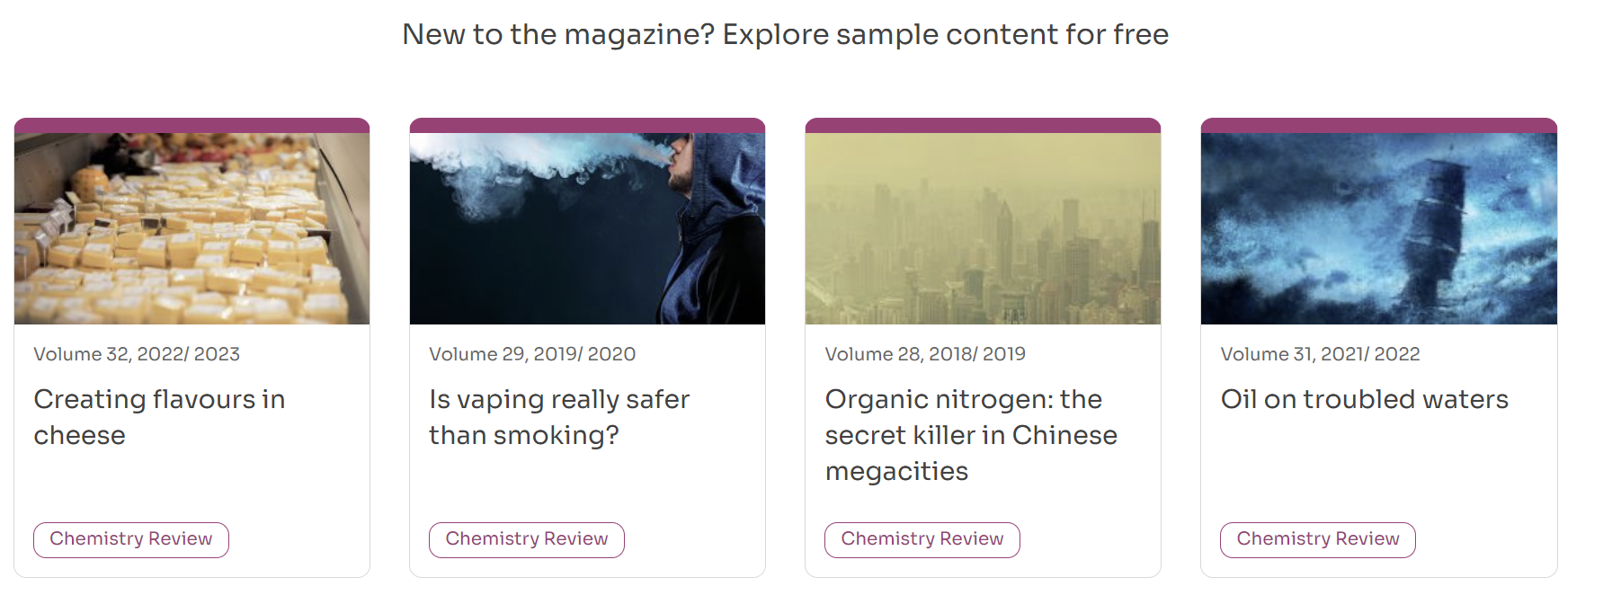

Choose one of the articles to read fully, and then write a short summary (approximately 300 -400 words) of the science within the article.

Note: The articles may contain lots of unfamiliar chemistry, including chemical names; therefore, focus on identifying and understanding the key points within the article.

Extra Wider Reading/Activities to keep you busy during the summer…

Books:
- Edexcel A-Level Chemistry Student Book 1
- The Disappearing Spoon – Sam Kean, 2011
- Periodic Tales: The Curious Lives of Elements – Hugh Aldersley-Williams, 2012
- Why Does Asparagus Make Your Wee Smell? And 57 Other Curious Food and Drink Questions – Andy Brunning, 2016
- Chemistry: A Very Short Introduction – Peter Atkins, 2015

Magazines/Journals:
- New Scientist
- Nature Briefing
- Chemistry World

Websites:
- Periodic Videos by Martyn Poliakoff on YouTube
- Chemguide.co.uk
- Chemrevise.org
- A Future in Chemistry – Royal Society of Chemistry https://edu.rsc.org/future-in-chemistry

