Wider Reading in Biology

Wider reading, or ‘reading around your subject’, is important in A-Level study. Wider reading provides you with a broad base of knowledge and enhances your scientific communication skills.

Go to: https://www.hoddereducationmagazines.com/magazines/biological-sciences-review/

Scroll down the free sample articles:
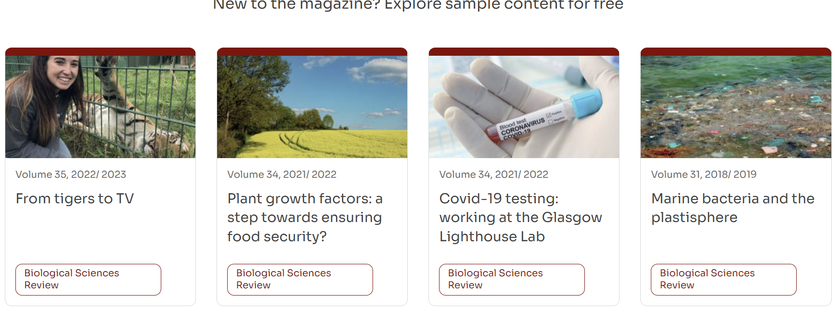

Choose one of the articles to read fully, and then write a short summary (approximately 300 – 400 words) of the science within the article.

Note: The articles may contain lots of unfamiliar biology, including scientific terminology or biological processes; therefore, focus on identifying and understanding the key points within the article.

Wider Reading/Activities to keep you busy during the summer…

Books:
These can be ordered through the Essex Library service and then delivered to the Southminster, Burnham or Mobile library. Alternatively, they are available second-hand online (eBay or Amazon would be worth a look). They can also be borrowed from Mrs Hoare.

- Edexcel A-Level Biology Student Book 1
- James Watson: DNA: The Secret of Life
- Richard Dawkins: The Selfish Gene
- Richard Sheppard – The seven ages of death

Magazines/Journals:
- New Scientist
- Nature Briefing

Websites:
- Miss Estruch Biology on YouTube https://www.youtube.com/@MissEstruchBiology
- Mr Exham on YouTube
- SnapRevise on YouTube
- Physics and Maths Tutor https://www.physicsandmathstutor.com/biology-revision/a-level-edexcel-a/
- A Future in Biology – Royal Society of Biology https://www.rsb.org.uk

