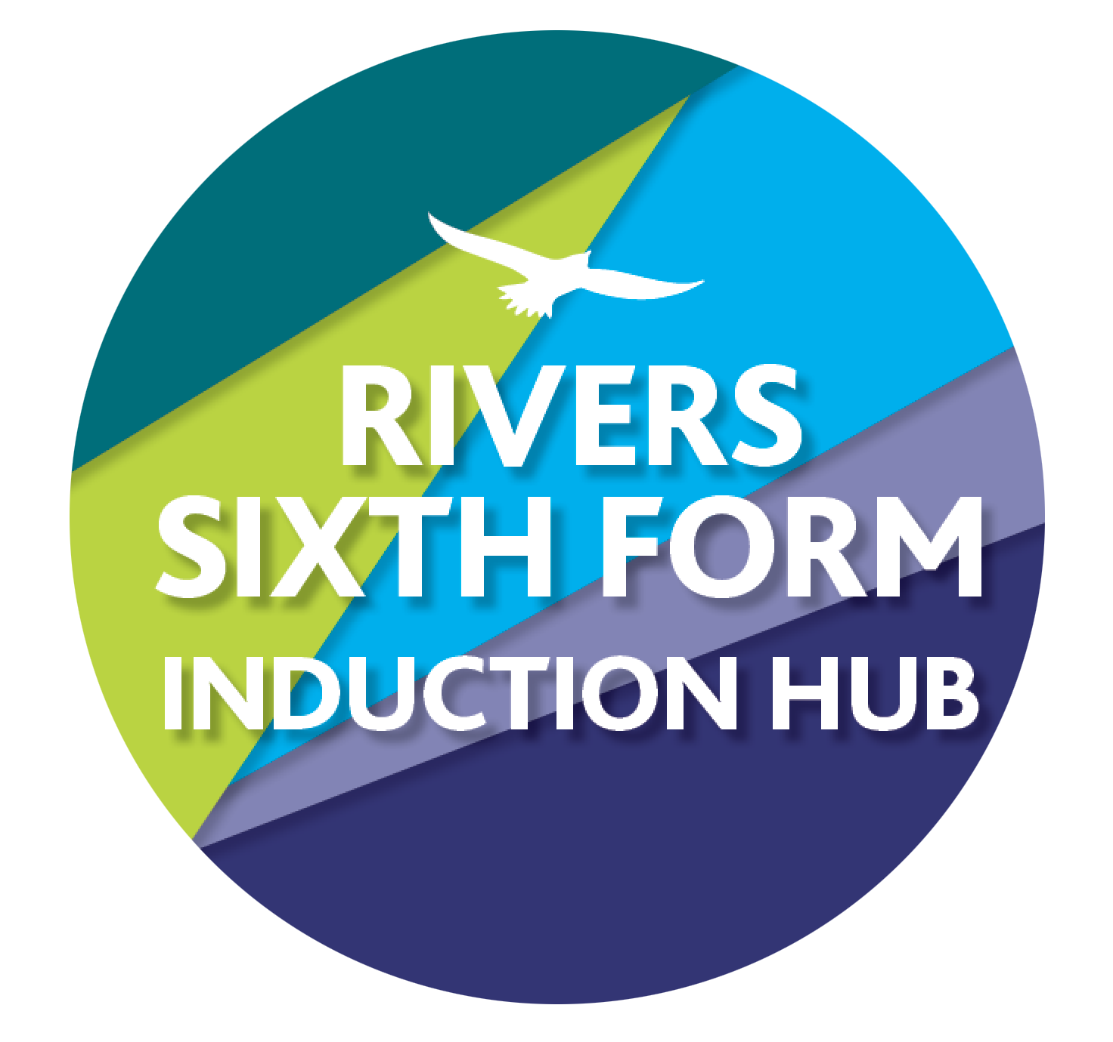

RIVERS TRANSITION CHALLENGE 2025

SUBJECT: Motor Vehicle Studies

Course details: City & Guilds

Qualification: Level 3 Diploma in Light Vehicle Maintenance and Repair Principles

Minimum entry requirement is: Maths: grade 4. Engineering: Pass or above preferable but not essential.

Teacher: Dr. K. Rumary [krumary@ormistonriversacademy.co.uk](mailto:krumary@ormistonriversacademy.co.uk)

YOUR CHALLENGES:

**Challenge 1:**

The 2 stroke and 4 stroke cycle.

Produce an illustrated guide to demonstrate the function of the different cycles of two and four stroke engines. While this could simply be produced as a poster there are a number of other possibilities dependent on your creativity. Here are some ideas.

-Produce a cardboard model

-Produce an animation

-Make a video to explain the processes

**How this links to the specification:**

The understanding of the four and two stroke engine is part of unit 208: Engine types and principles

**Time guide: 4 hrs**

**Assignment deadline: First day back**

**Here is what it could look like.**

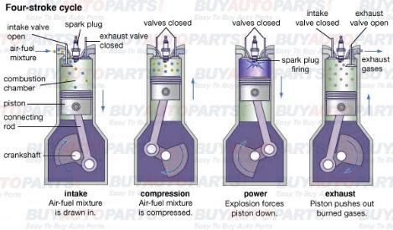

**SUPPORT:** Use <http://www.animatedengines.com/>

**Challenge 2:**

This is by far the hardest challenge. I would not have set it, but recently a year 8 managed it and sent us a video of her attempt.

I think Dots and Melons would be a good place to go for some of the stuff you may need for this.

This is going to test your reading and making skills!

Go to this website

[Simple Coke Can Engine : 14 Steps (with Pictures) - Instructables](https://www.instructables.com/Simple-coke-can-engine/)

Plan out what you need, then make it. If you are really short of things, we may be able to have a rummage at school.

Make a video of your engine, working or not.

**How this links to the specification:**

The use of tool and equipment safely underpins the core knowledge of workshop practice. It is also a good opportunity to get to grips with how a Stirling engine works

**SUPPORT:** You can email us for further help.

**Time guide: 8 hrs**

**Assignment deadline: First day back!**

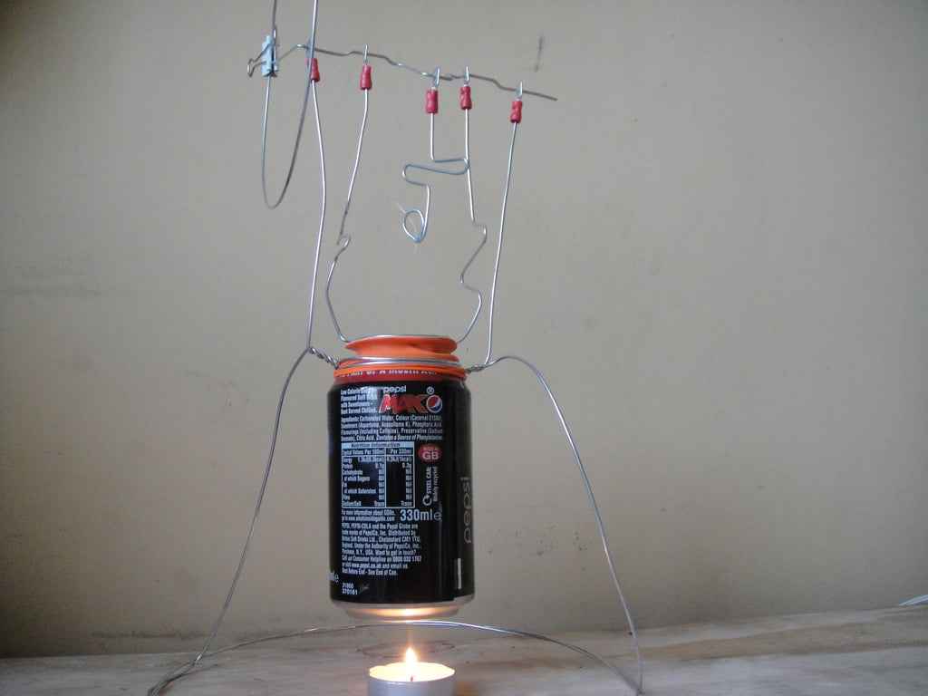

HOW DO I HAND IN?

Your work must be handed in via email so that it can be assessed and marked accordingly.

HOW AM I MARKED?

You are graded using Pass, Merit or Distinction. The tasks are tricky because it’s Sixth Form and KS5 study and there is a big jump. You will need to spend significant time learning the concepts and techniques and theory.

HOW AM I MARKED?

We would expect new students to any course to be sitting at the bottom of the grading structure, BUT! There are certain activities that you will be familiar with and will do better with even though it's just the start of the course. Please don't worry if you receive Us, you will get better.

WHAT IF I GET STUCK?

Then email me, my email is in the title of this sheet or write on the thread in our classroom, we know some things are tricky and are here to help!

WHAT IF I MISS A DEADLINE OR DON’T HAVE I.T?

THEN YOU NEED TO LET ME KNOW WAY IN ADVANCE SO WE CAN SUPPORT YOU, IF YOU JUST MISS THE DEADLINE YOU ARE RISKING YOUR COURSE OFFER.

**THATS’S IT! Good luck and don’t miss your deadlines!**