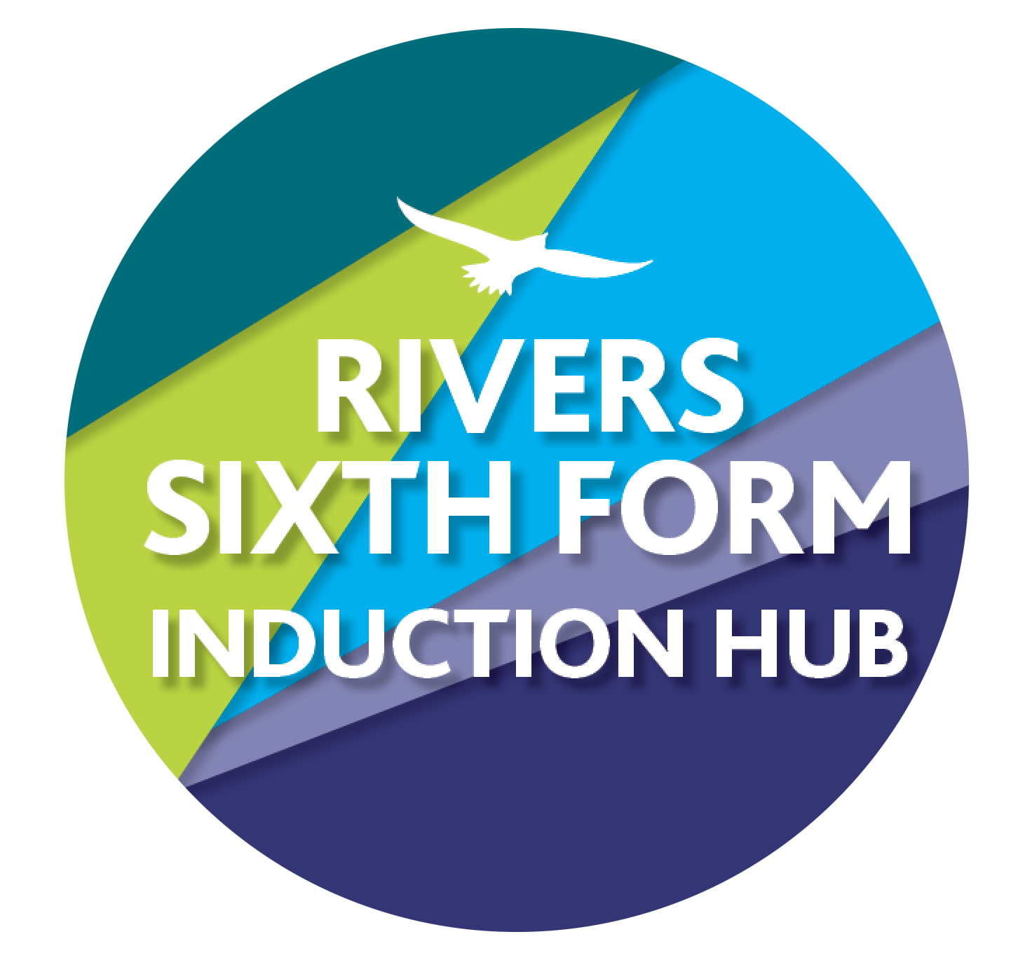

RIVERS Bridging Work 2025

SUBJECT: Physics

Course details: Pearson Edexcel

Qualification: A Level

Minimum entry requirements are:

* Grade 6 in Physics or 6/6 in Combined Science
* Grade 6 in English
* Grade 6 in Mathematics

Teachers to contact:

* Mr Harland [jharland@ormistonriversacademy.co.uk](mailto:jharland@ormistonriversacademy.co.uk)
* Mr Tompkin [ptompkin@ormistonriversacademy.co.uk](mailto:ptomkin@ormistonriversacademy.co.uk)

A-Level physics is a demanding course that requires a great deal of mathematical competency, it is important to approach it fully prepared. The aim of these tasks is to re-enforce and consolidate the key knowledge and understanding from GCSE’s that forms a basis to build upon at A-level.

Your Tasks:

1. **SI Base Units, Precision, Accuracy, Reliable, Reproducible and Resolution**

Research what the SI base units are (there are seven of them) and what SI stands for. Research and then explain the difference between precision and accuracy. Define the terms Reliable, Reproducible and Resolution

Time guide: approx.1 hour

**How this links to the specification:**

Topic 1: Working as a Physicist. Essential throughout the whole course.

1. know and understand the distinction between base and derived quantities and their SI units

2. demonstrate their knowledge of practical skills and techniques for both familiar and unfamiliar experiments

**SUPPORT:**

[https://www.physicsandmathstutor.com/physics-revision/a-level-edexcel/working-as-physicist](https://www.physicsandmathstutor.com/physics-revision/a-level-edexcel/working-as-physicist/)

<https://www.alevelphysicsonline.com/quantities-and-units>

There are some images on the internet which explain the difference between precision and accuracy well. You may use these.

1. **Prefixes and Conversions, Equations and Calculations**

Research and produce flashcards or another revision resource for the standard Physics prefixes Complete the worksheets, following the instructions Prefixes and Conversions Worksheet Physics Calculations Worksheet

Time guide: approx. 2 hours

**How this links to the specification:**

Mathematical Skills., Essential throughout course

C.0 – arithmetic and numerical computation

C.1 – handling data

C.2 – algebra

**SUPPORT:** Follow the instructions on the worksheet. Use the [Formulae Sheet](https://drive.google.com/file/d/1fIb8F0NqlweWoPFntEzdY1g3J4Q2bTd5/view?usp=sharing) for the equations. Show your workings clearly when doing the calculations and follow the examples on the worksheets

1. **Complete the GCSE to A Level Transition Test**

Please attempt this as a closed book assessment in black pen and then please complete the paper again using whatever resources you wish, filling in any gaps in blue pen.

Time guide: 3 hours

**How this links to the specification:**

Exam Practice, Working Scientifically, Practical skills and Mathematical Skills. Essential throughout course

**SUPPORT:**

[**https://www.alevelphysicsonline.com**](https://www.alevelphysicsonline.com/practical-skills)

[**Physics Revision - PMT (physicsandmathstutor.com)**](https://www.physicsandmathstutor.com/physics-revision/)

1. **Research Skills**

To get the best grades in A Level Physics you will have to get good at completing independent research and making your own notes on difficult topics. Below are links to 5 websites that cover some interesting Physics topics. Using the Cornell notes system (<http://coe.jmu.edu/learningtoolbox/cornellnotes.html>) make 1 page of notes on one topic from the examples below:

a) <http://home.cern/about>

CERN encompasses the Large Hadron Collider (LHC) and is the largest collaborative science experiment ever undertaken. Find out about it here and make a page of suitable notes.

b) <http://joshworth.com/dev/pixelspace/pixelspace_solarsystem.html>

The solar system is massive and its scale is hard to comprehend. Have a look at this award winning website and make a page of suitable notes.

c) [https://phet.colorado.edu/en/simulations/category/html PhET](https://phet.colorado.edu/en/simulations/category/html)

You can complete some simple experiments online. Open up the resistance of a wire simulation. Conduct a simple experiment and make a one page summary of the experiment.

d) <http://climate.nasa.gov/> 7 © Copyright The PiXL Club Ltd,

2016 NASA’s Jet Propulsion Laboratory has lots of information on Climate Change and Engineering Solutions to combat it. Have a look and make notes on an article of your choice.

e) <http://www.livescience.com/46558-laws-of-motion.html>

Newton’s Laws of Motion are fundamental laws for the motion of all the objects we can see around us. Use this website and the suggested further reading links to make notes.

Time guide: Approx. 2 hours

**How this links to the specification:**

Working Scientifically. Essential for the 16 core practicals

**SUPPORT:** [**https://slideplayer.com/slide/15069814/**](https://slideplayer.com/slide/15069814/)

How do I hand in my work?

Your work must be handed in the first lesson of the new academic year.

How am I marked?

You are graded using A to E grades using standard grade boundaries. The tasks may be difficult because it’s Sixth Form and KS5 study and there is a big jump from GCSE. You will need to spend significant time learning the concepts and techniques. We would expect new students to any course to be sitting at the bottom of the grading structure, but there are certain activities that you will be more familiar with and will do better with.

What if I get stuck?

Then email me, my email is in the title of this sheet or post a message in teams, we know some things are tricky and are here to help!

What if I miss a deadline?

You need to let us know in advance so we can support you. If you miss the deadline, you are risking your course offer.

Wider Reading/Activities to keep you busy in the summer…

Books:

* Edexcel A-Level Physics Student Book 1
* The Feynman Lectures on Physics – Richard Feynman
* The Strange Case of Mrs. Hudson’s Cat – Colin Bruce
* A brief history of time – Stephen Hawking
* The new quantum universe - Hey and Walters

Magazines/Journals

* New Scientist
* Physics Today
* Physics World

Websites:

* Various YouTube channels: Veritasium, Physics girl, Minute physics, 60 symbols, physics for the birds
* [https://phet.colorado.edu/en/simulations/category/html PhET](https://phet.colorado.edu/en/simulations/category/html)
* [https://www.alevelphysicsonline.com](https://www.alevelphysicsonline.com/practical-skills)
* [Physics Revision - PMT (physicsandmathstutor.com)](https://www.physicsandmathstutor.com/physics-revision/)