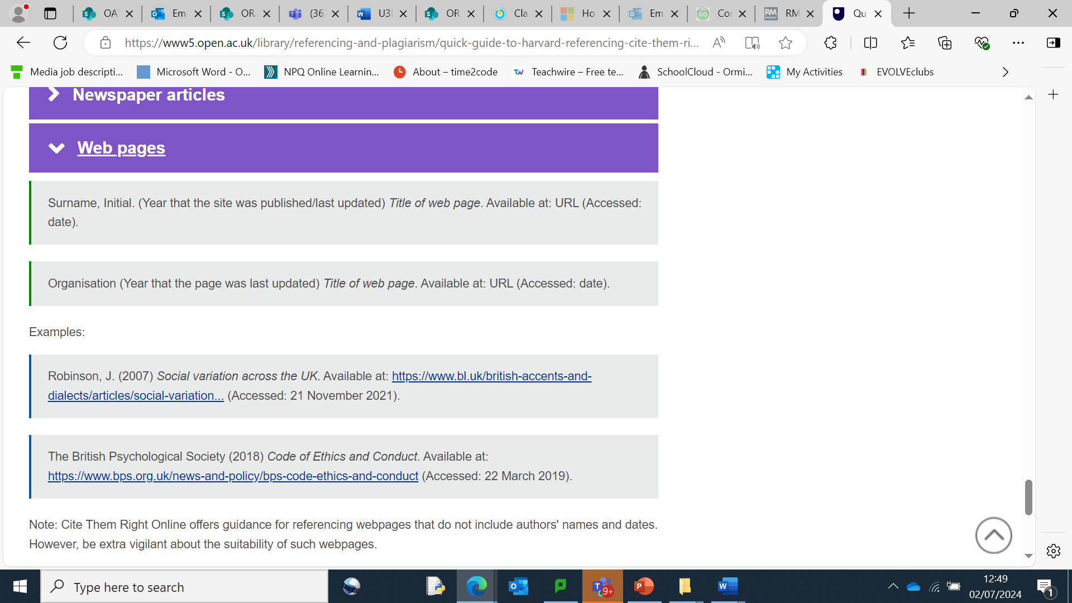

You can use this Website:

[Free Harvard Referencing Generator [Updated for 2024] (mybib.com)](https://www.mybib.com/tools/harvard-referencing-generator)