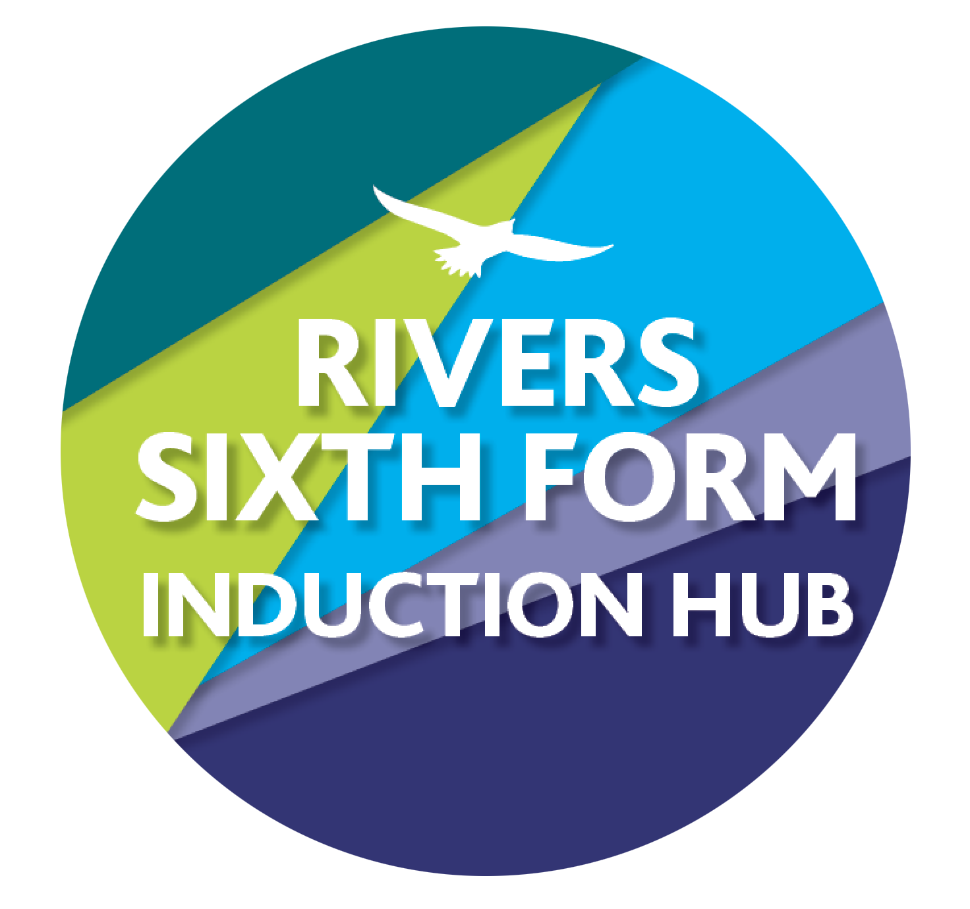

RIVERS TRANSITION CHALLENGE 2025

SUBJECT: Biology

Course details: Pearson Edexcel

Qualification: A Level

Minimum entry requirements are:

* Grade 6 in Biology or 6/6 in Combined Science
* Grade 4 in English
* Grade 4 in Mathematics

Teachers to contact:

* Mrs Hoare [choare@ormistonriversacademy.co.uk](mailto:choare@ormistonriversacademy.co.uk)
* Mrs Morgan [amorgan@ormistonriversacademy.co.uk](mailto:amorgan@ormistonriversacademy.co.uk)
* Ms Neary [mneary@ormistonriversacademy.co.uk](mailto:mneary@ormistonriversacademy.co.uk)

A-Level biology is a challenging course, and it is important to approach it fully prepared. The aim of these tasks is to re-enforce and consolidate the key knowledge and understanding from GCSE’s that underpins the A-Levels content, giving a firm base to build from.

**Your Tasks**

1. **Cell Membrane**

Research the fluid mosaic model, including details of the phospholipid bilayer and other structures such as proteins, cholesterol and glycolipids.

You may present your findings as a poster or a 3D model with explanations for each of these structures.

Stretch and Challenge: Describe the processes by which substances pass through cell membranes. These include diffusion, facilitated diffusion, osmosis, active transport, exocytosis and endocytosis.

Time guide: approx. 1.5 - 2 hours

**How this links:**

GCSE: Topic 1: Cell Biology

A-Level: Topic 2: Genes and Health

1. **Cardiac Cycle**

Draw a diagram showing the events that occur in the cardiac cycle: atrial systole, ventricular systole and cardiac diastole. Relate the structure and operation of the mammalian heart, including the major blood vessels, to its function.

Stretch and Challenge: Use further sources to research perfect answers and add to your work in a different colour pen.

Time guide: approx. 1 – 1.5 hours

**How this links:**

GCSE: Topic 2: Organisation

A-Level: Topic 1: Lifestyle, health and risk

1. **GCSE to A Level Transition Test**

Complete the transition test. We will be reviewing this in class when you start in September.

It is important we accurately assess your starting point on this course; therefore, refrain from using resources to help you.

Time guide: 2 hours.

1. **Wider Reading**

Wider reading, or ‘reading around your subject’, is important in A-Level study. Wider reading provides you with a broad base of knowledge and enhances your scientific communication skills.

Go to: <https://www.hoddereducationmagazines.com/magazines/biological-sciences-review/>

Scroll down the free sample articles:

Choose one of the articles to read fully, and then write a short summary (approximately 300 – 400 words) of the science within the article.

*Note: The articles may contain lots of unfamiliar biology, including scientific terminology or biological processes; therefore, focus on identifying and understanding the key points within the article.*

Time guide: 1 hour

**Key Information**

How do I hand in?

Your work for all four tasks must be handed in during our first lesson in September.

How am I graded during Year 12 and Year 13?

You are graded using A to E grades using standard grade boundaries. The tasks may be difficult because there is a big jump from GCSE to Sixth Form study.

We would expect new students to any course to be sitting at the bottom of the grading structure, but there are certain activities that you will be more familiar with and will do better with.

What if I get stuck?

Email us! Our emails are on the front sheet, we know some things are tricky and are here to help!

What if I miss a deadline?

You need to let us know in advance so we can support you. If you miss the deadline, you are risking your course offer.

Wider Reading/Activities to keep you busy during the summer…

**Books:**

These can be ordered through the Essex Library service and then delivered to the Southminster, Burnham or Mobile library. Alternatively, they are available second-hand online (eBay or Amazon would be worth a look). They can also be borrowed from Mrs Hoare.

* Edexcel A-Level Biology Student Book 1
* James Watson: DNA: The Secret of Life
* Richard Dawkins: The Selfish Gene
* Richard Sheppard – The seven ages of death

**Magazines/Journals:**

* New Scientist
* Nature Briefing

**Websites:**

* Miss Estruch Biology on YouTube <https://www.youtube.com/@MissEstruchBiology>
* Mr Exham on YouTube
* SnapRevise on YouTube
* Physics and Maths Tutor <https://www.physicsandmathstutor.com/biology-revision/a-level-edexcel-a/>
* A Future in Biology – Royal Society of Biology <https://www.rsb.org.uk>