RIVERS TRANSITION CHALLENGE 2024
SUBJECT: SOCIOLOGY
Course details: OCR
Qualification: A Level

Minimum entry requirement: English: 5
Teacher: Mrs T Cope tcope@ormistonriversacademy.co.uk
Teacher: Mrs French mfrench@ormistonriversacademy.co.uk

Task:

You must select one from each category and write a reflection on their impact. Questions to consider in writing this:
● What was the message?
● What did you find interesting?
● What new information did you learn?
● What questions do you still have?
● How do you think it relates to A-level Sociology?
● What links are there to gender, age, ethnicity, or social class?
● Are there links to your topics?
How do I do it?
● Write a report on each category (A4 page is enough)
● Create a storyboard for each of these
● Create an A4 mind-map
Deadline for submission is 1st September 2024
Reading:
'Natives' by Akala
Invisible Women by Criado Perez
She Speaks By Yvette Cooper
Class & Education Diane Reay
When do gendered roles within the family start?
What About Men? (Audio Download): Caitlin Moran, Caitlin Moran, Penguin Audio: Amazon.co.uk: Books

Choose at least one task from each box. These tasks will help to prepare you to begin the course and ensure you have chosen the subject wisely.
Compulsory listening: Studying sociology for the first time
Sociology Summer task

Watching:
American Son
Crime Files
Stacey Dooley Costa del Narcos
Being Black and British
Is uni racist?
21 Up a study of growing up
The wisdom of sociology
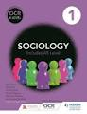
Purchase your textbook and ensure your device is sixth form ready.
It is also useful to obtain some flashcards, coloured paper and a whiteboard pen.
Listening:
Key terms if you're new to Soc
Education & the working class
Organised crime
Love Island
Gang leader for a day
Gender roles in the family
Reading:
'Natives' by Akala
Invisible Women by Criado Perez
She Speaks By Yvette Cooper
Class & Education Diane Reay
When do gendered roles within the family start?
What About Men? (Audio Download): Caitlin Moran, Caitlin Moran, Penguin Audio: Amazon.co.uk: Books

Use this a prompt. An A4 page is expected to be submitted for each task
Choose at least one task from each box. These tasks will help to prepare you to begin the course and ensure you have chosen the subject wisely.
Compulsory listening: Studying sociology for the first time

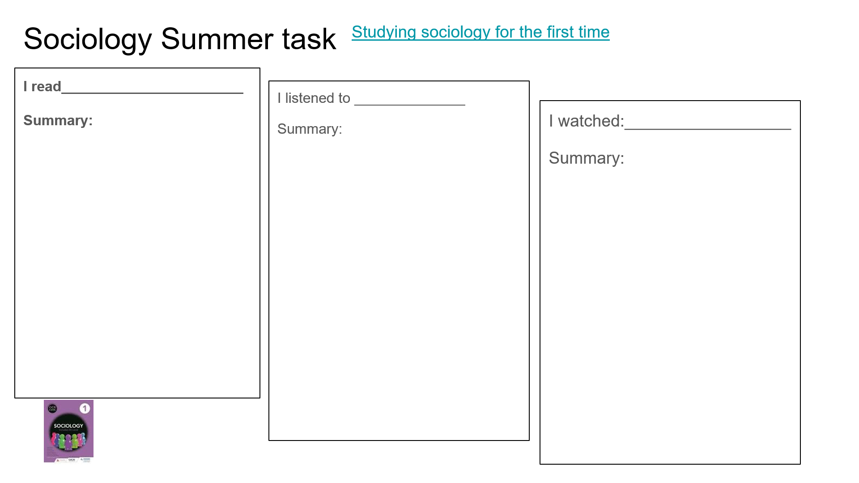

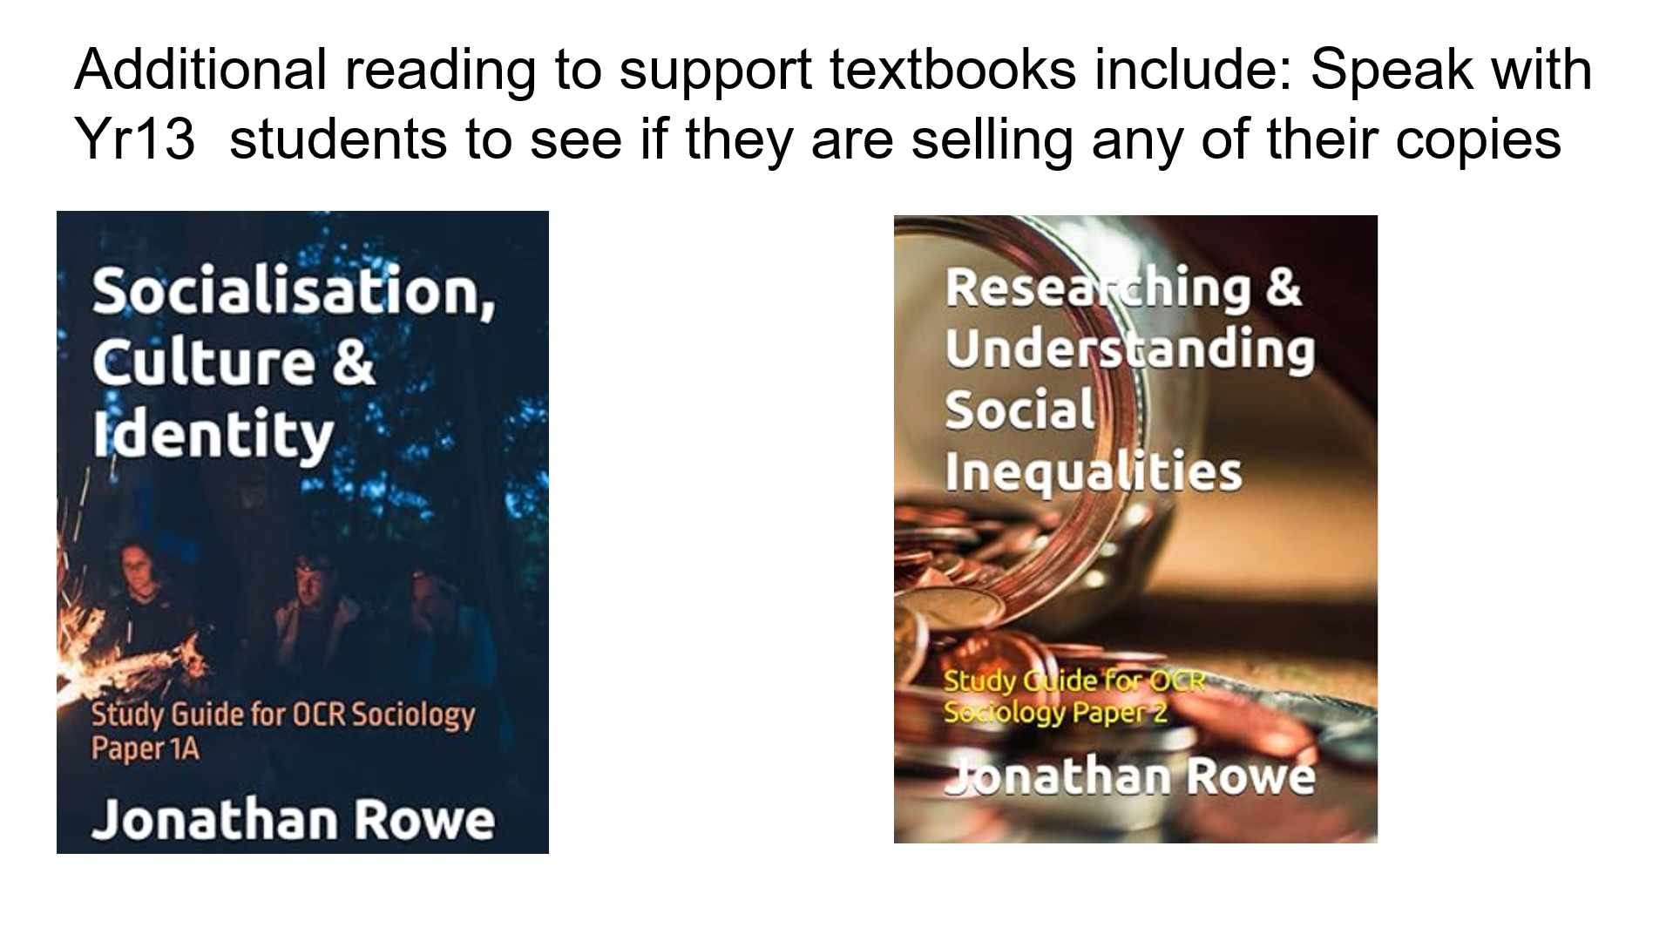

Read through the following exam paper and answer structures and familiarise yourself with the structures and style of questions that the three papers will test you on. Look for similarities between subjects and approaches for you GCSE’s. You will have support in class to adapt to the exam requirements.

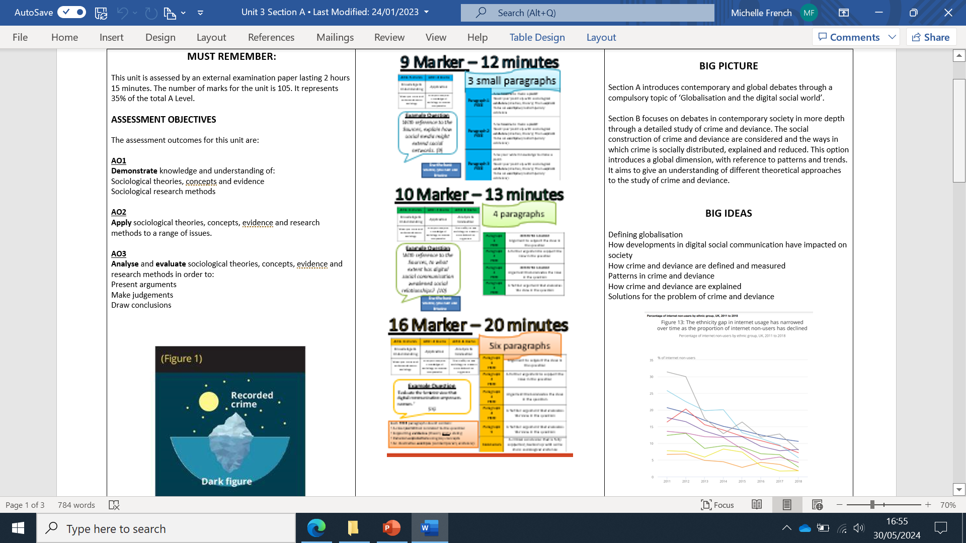
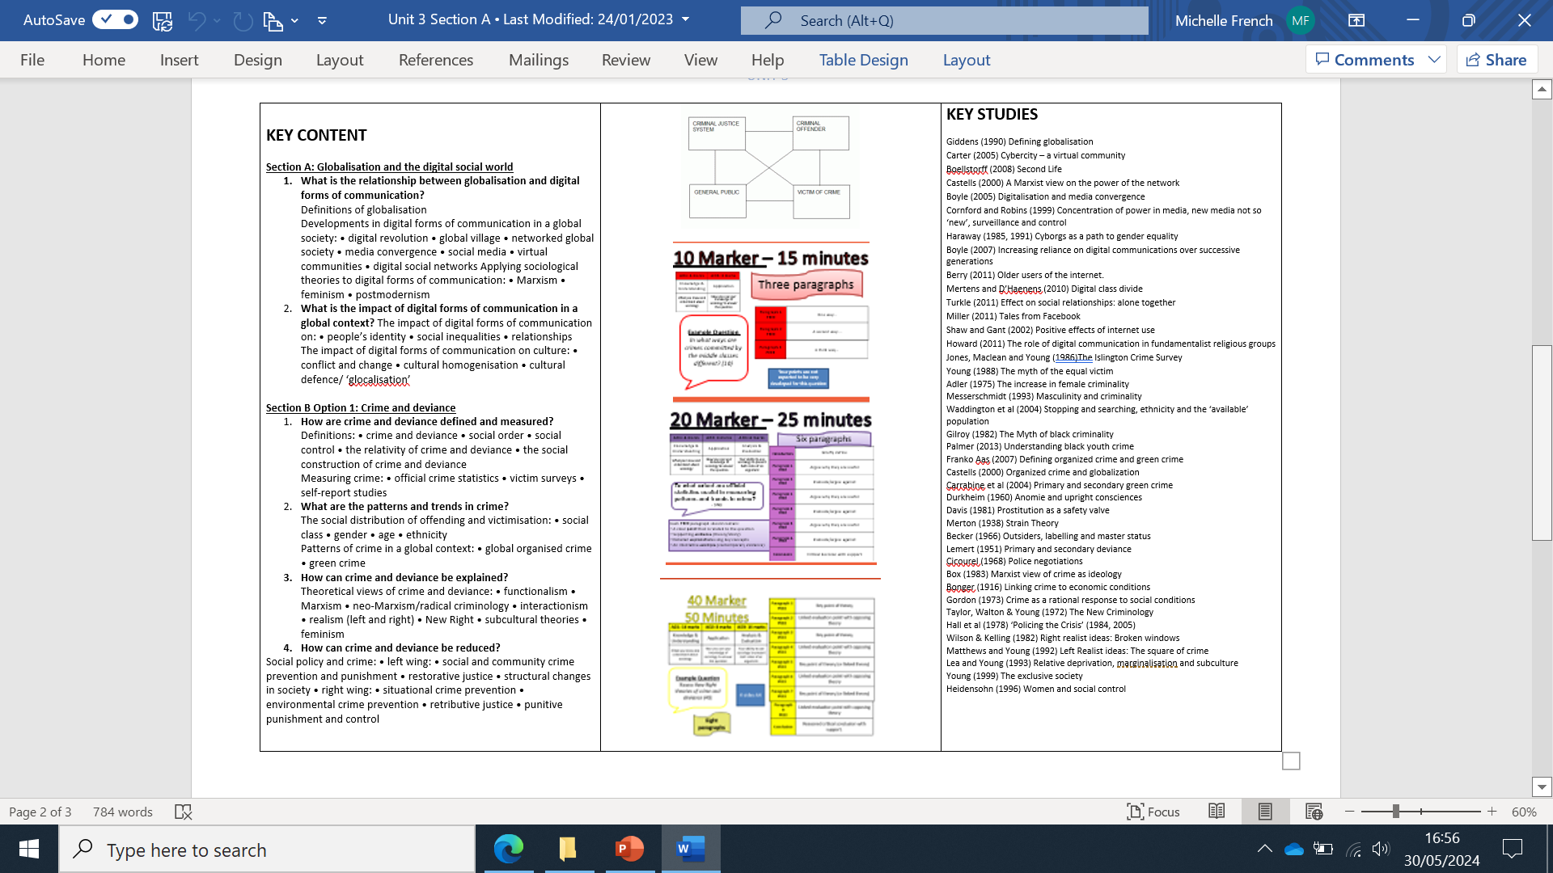

Good luck and we look forward to seeing you in class in September 2024

