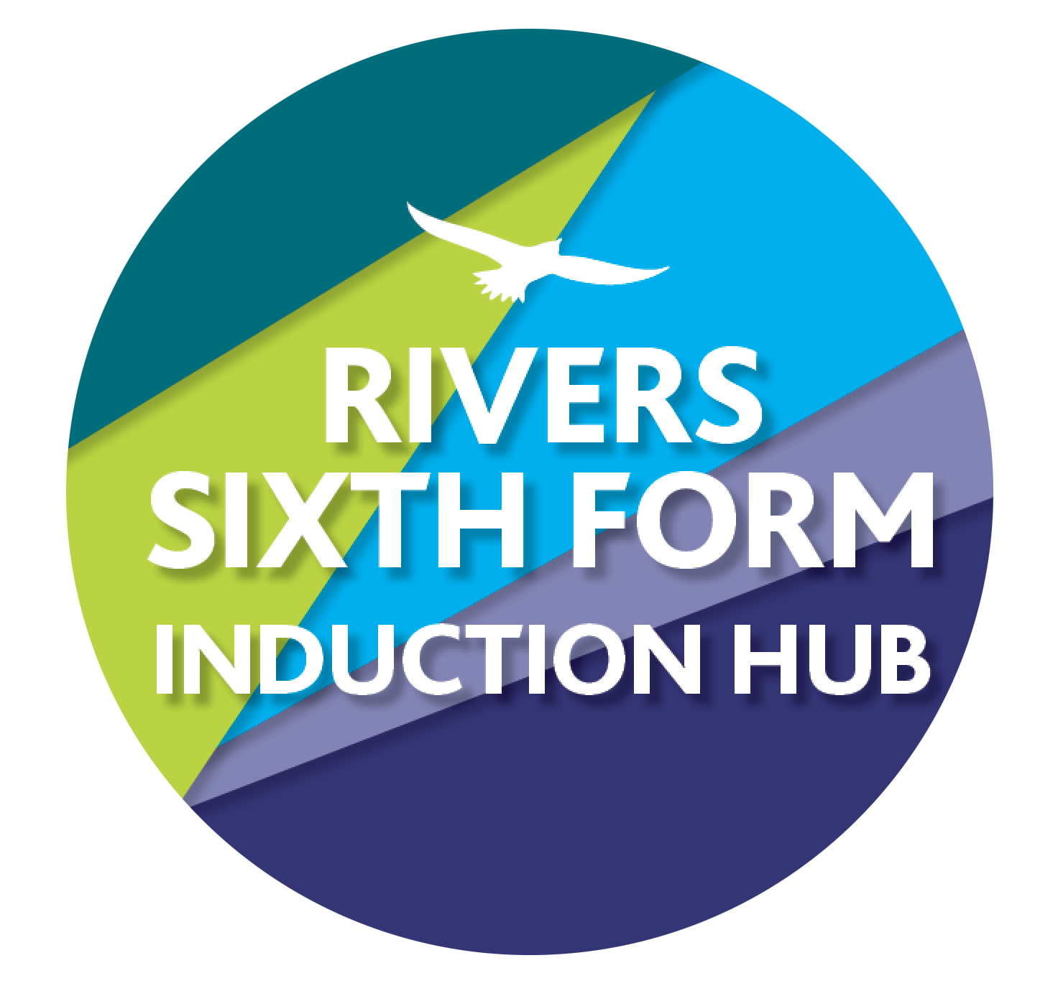
RIVERS TRANSITION CHALLENGE 2023
SUBJECT: Psychology
Course details: AQA exam board.
Qualification: A level

Minimum entry requirement is: Grade 5 in a Science and English
Teacher for Psychology: Mr Chapman rchapman@ormistonriversacademy.co.uk

YOUR CHALLENGES:
Challenge 1: What is Psychology and where does it come from?
To answer the first question, it’s the science of mind and behaviour, but it hasn’t always been that way.

Research and record notes on the following key stages in the development of Psychology as a subject. Focus on what each approach assumes about the human mind and what their key ideas are for explaining the thinking and behaviour of people.

Philosophical Origins- Ancient Greeks, Rene Descartes, and Emmanuel Kant

Phrenology- Franz Gall

Psychophysics- Ernst Weber and Gustav Fechner

The First Psychologists- Wilhelm Wundt and William James

Psychoanalysis- Sigmund Freud

How this links to the specification: Our first topic in A-Level Psychology is about approaches, as there is no single way all Psychologists agree on how the human mind functions. These topics give a good background on where Psychology came from and how it eventually developed into one of the newest sciences.

Time guide: 3 hrs
Assignment deadline: 1st September

EXEMPLARS: GRADES A*-E: See grade descriptors after the two challenges

SUPPORT:
You’ll be able to find ample information online but here are some links to get you started-
https://samplius.com/free-essay-examples/the-history-of-mental-health-researches/
https://plato.stanford.edu/entries/kant-mind/
https://www.brainybehavior.com/blog/2008/01/descartes-and-modern-psychology/
https://www.britannica.com/topic/phrenology
https://www.britannica.com/science/psychophysics
https://www.simplypsychology.org/wundt.html
https://www.simplypsychology.org/william-james.html
https://www.simplypsychology.org/sigmund-freud.html

Challenge 2: Cognitive Dissonance

- Research what Cognitive Dissonance is and write a definition of this interesting aspect of human behaviour.
- Look up the Cognitive Dissonance Experiment by Leon Festinger and James Carlsmith in 1957 at Standford University (when talking about this study you would simply say Festinger and Carlsmith, 1957). What were the aims of the experiment, what was their procedure, what were the results, and what do these results tell us?
- Now that you know what Cognitive Dissonance is, find an example of this in normal life and explain how the process worked in a real setting.
- Find evidence that either supports or opposes this theory. You’ll want to find other experiments which might have confirmed or contradicted these results or talk about what is or isn’t reliable in the original study.

How this links to the specification: In A-Level Psychology we look at theories and ideas in three main categories for assessment. AO1- Knowledge and understanding of scientific ideas, processes, techniques, and procedures. AO2- Application of Psychological ideas to real world or theoretical settings. AO3- Analysis and evaluation. This challenge will show you how we do all three.

Time guide: 2 hrs
Assignment deadline: 1st September

EXEMPLARS: GRADES A*-E: See grade descriptors after the two challenges

SUPPORT:
https://www.simplypsychology.org/cognitive-dissonance.html

EXEMPLARS:
Grade descriptors
A*- Securely meet all the requirements of grade A with a stronger performance in all of them.
A- Accurate and detailed knowledge of a range of relevant scientific ideas, processes, techniques, and procedures with a information clearly presented and proper terminology used. Explicit and effective application of knowledge to real world and hypothetical scenarios. Analyse, interpret, and evaluate scientific information with the ability form strong judgements.
B- Same as A grade except less consistent with quality of answers and some inaccuracies and misunderstandings shown.
C- Reasonably accurate and detailed knowledge of some scientific ideas, processes, techniques, and procedures. Mostly clearly presented and some proper terminology used. Application of relevant knowledge to real world or hypothetical scenarios. Analyse, interpret, and evaluate some scientific information with a judgement formed.
D- Securely meeting all requirements for grade E with stronger performance in each area but not enough to reach grade C.
E- Some basic knowledge of relevant scientific ideas, processes, techniques, and procedures presented with basic psychological terminology. An attempt to apply some psychological knowledge to real world or hypothetical scenarios. An attempt to analyse, interpret, and evaluate some relevant scientific information with basic judgements formed.

HOW DO I HAND IN:
Your work must be handed in as paper copies on the first class in September.

HOW AM I MARKED?
You are graded using A*-E grades based on AQA Psychology mark scheme levels. These are outlined in brief here but can be found in more detail from either the AQA website or from the JCQ definitions. You’ll start the year on the lower end but this is nothing to panic about- this a new subject and a big jump in difficulty from KS4. As you learn the subject and get used to the style of Psychology writing your grades will reflect your progress.

WHAT IF I GET STUCK?
Email me! I’ll get back to you as soon as I can and frankly I love to talk Psychology anyway.

WHAT IF I MISS A DEADLINE OR DON’T HAVE I.T?
This will be a new subject for the vast majority of you and so this work is essential for familiarising yourself with the subject. If you have a reason then make sure you communicate it but ensure the work is completed or it will seriously affect your ability to take this subject.

WIDER READING/ACTIVITIES TO KEEP YOU BUSY IN THE SUMMER
For research you can use the links I have provided above. In general, SimplyPsychology is a great website and is ideal for A-Level Psychology.

Books:
AQA PSYCHOLOGY FOR A LEVEL YEAR 1 & AS STUDENT BOOK – 2ND EDITION (the green hair book)
Thinking, Fast and Slow by Daniel Kahneman
Self Comes to Mind by Antonio Damasio
Synaptic Self: How Our Brains Become Who We Are by Joseph LeDoux

Film/TV:
Freud (Netflix)
Hitler’s Circle of Evil (Netflix)
Lost Angels: Skid Row is My Home (Prime)
Memento (Netflix)
Mindhunters (Netflix)
Neurons to Nirvana (Netflix)
OC87: The Obsessive Compulsive, Major Depression, Bipolar, Asperger’s Movie (Prime)
Of Two Minds (Prime)
Shutter Island (Netflix)
Take your pills (Netflix)
The Anonymous People (Prime)
The Mind, Explained (Netflix)
The Social Dilemma (Netflix)

National Governing Body:
British Psychological Society: https://www.bps.org.uk/

