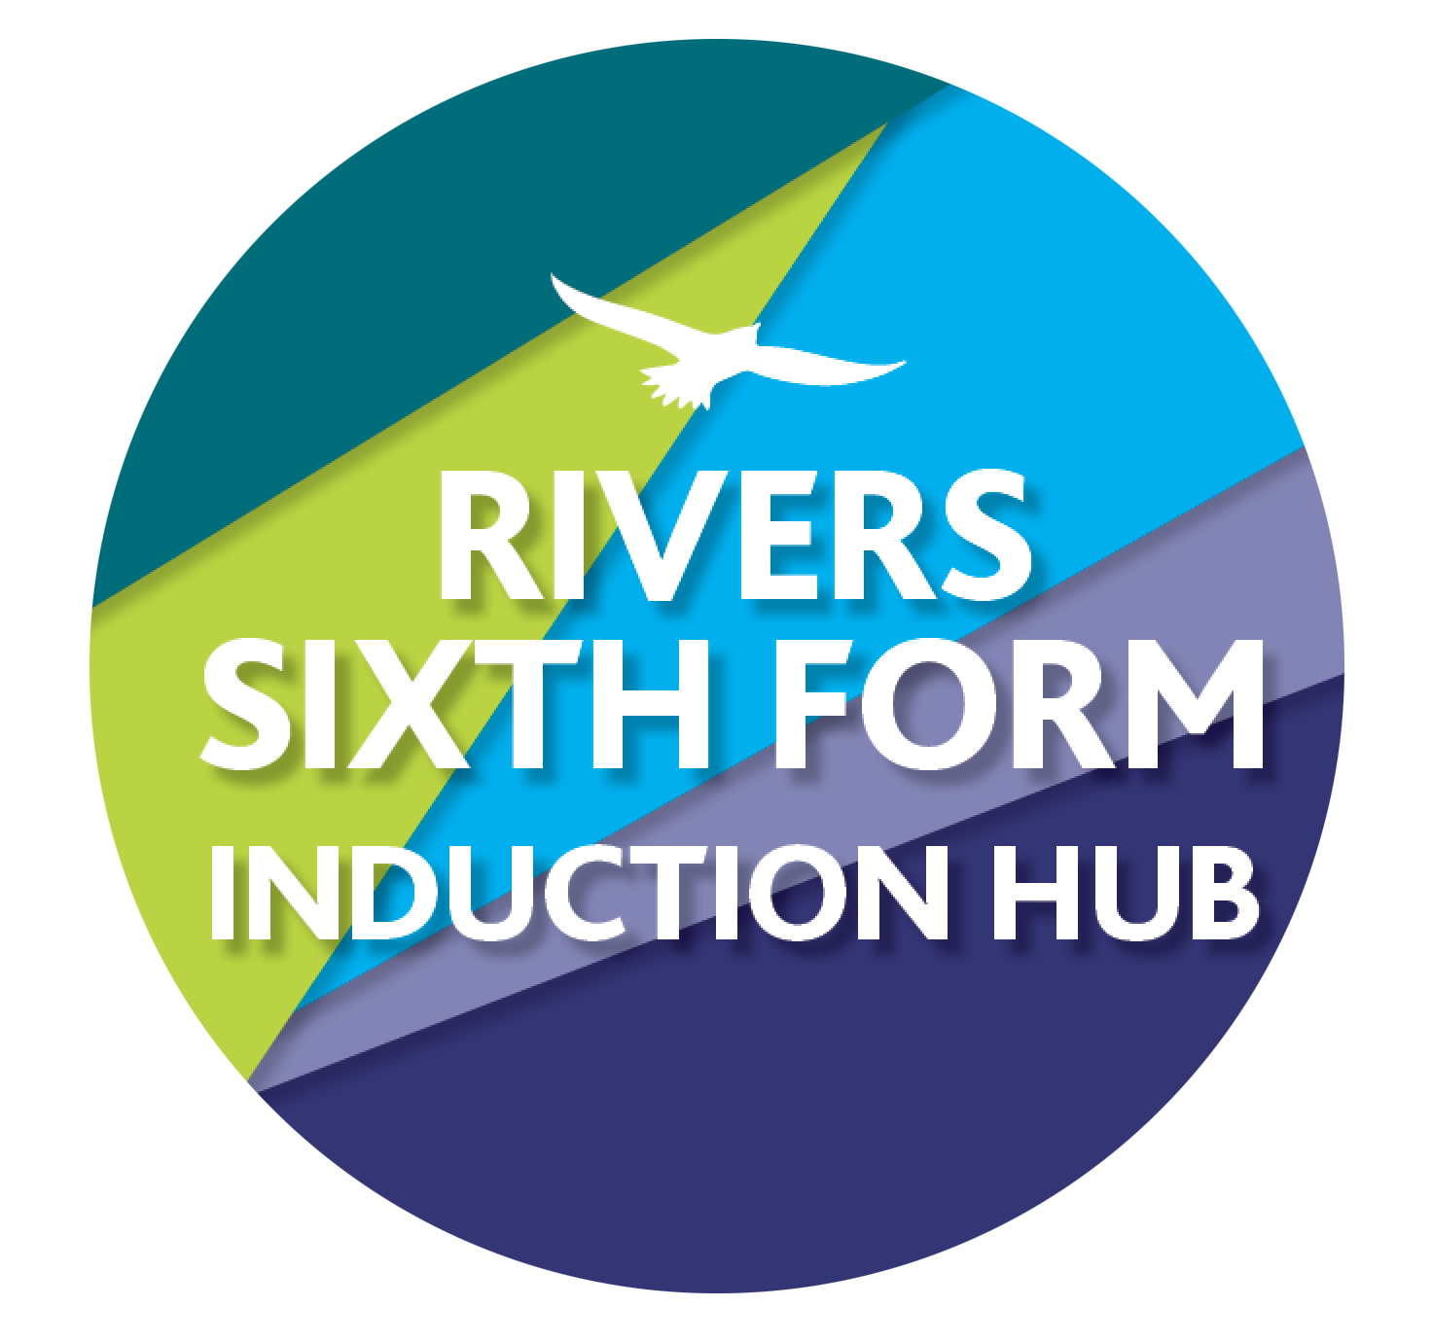
RIVERS TRANSITION CHALLENGE 2022
SUBJECT: ENGLISH LITERATURE
Course details: Exam board - AQA
Qualification: A Level

Minimum entry requirement is: GCSE Grade 6
Teacher: Ms J Smith
Email: jsmith@ormistonriversacademy.co.uk

Some of the course’s key texts are listed below, which you will need to purchase when doing the two-year course. At this point, you must pre-read the two novels highlighted in bold.

The Great Gatsby - F. Scott-Fitzgerald (Penguin Modern Classics)
The Handmaid’s Tale – Margaret Atwood (Vintage)
A Streetcar Named Desire - Tennessee Williams (Penguin Modern Classics)
Skirrid Hill - Owen Sheers (Seren) - you can find it on Amazon here: https://www.amazon.co.uk/Skirrid-Hill-Owen-Sheers/dp/1854114034/ref=sr_1_1?dchild=1&keywords=skirrid+hill&qid=1623402248&s=books&sr=1)

In Y13:
Othello – William Shakespeare (studied in Y13)
Coursework Text – most likely A Doll’s House - Henrik Ibsen

CHALLENGE 1: PRE-READING

- Read and enjoy the novel ‘The Great Gatsby’ by F. Scott Fitzgerald, paying attention to his characterisation and thematic ideas.

- Read at least the first 5 chapters of ‘The Handmaid’s Tale’ by Margaret Atwood, paying attention to her characterisation and thematic ideas.

CHALLENGE 2: LOVE THROUGH THE AGES POETRY:

- Research the life of Lord Byron, as well as the context behind his poem, ‘She Walks in Beauty’. A copy of this poem has been attached along with a handout with language and sentence terminology.
- Read Lord Byron’s ‘She Walks in Beauty’. Explore how Byron presents love in this poem, annotating a copy of the poem accordingly with language/structure/form techniques. Identify the effect of language, form and structure within your annotations.
- Research and find one other love poem and annotate it for techniques of language/structure/form. Identify the effect of language, form and structure within your annotations. Please also make some notes on the poem’s context as well.

- Write an essay answering the following question:

Compare how poets present love in ‘She Walks In Beauty’ and one other love poem of your choice, including links between texts and contexts.

Tip: Larkin, Donne, Blake, Yeats, Hardy are all good places to start for your research on the second poem. The more poems you can read as part of this task, the more you will benefit in the long run, as it is a fantastic start to wider reading for the course! A strong comparative essay will include a clear introduction, three comparative paragraphs and an effective conclusion. You should include analysis of how meaning is conveyed through language, form and structure, as well as commenting on the significance of contextual factors.

Time guide: This should take you approximately 5 hours
Assignment deadline: Please bring your essay to your FIRST lesson in September.

How it links to the Specification:
In Section C of Exam Paper 1: Love Through the Ages, you will need to write an essay comparing how a given theme is presented in one prose text and two poems. This task is very helpful for the comparative element because it gets you to compare two love poems.

SUCCESS CRITERIA: The keywords to remember when you’re writing your response are:
Band 5 | perceptive/assured
Band 4 | coherent/thorough
Band 3 | straightforward/relevant
Band 2 | simple/generalised
Band 1 | largely irrelevant, largely misunderstood, largely inaccurate
Ask yourself which band you’d fall into. Try and aim for band 5.
HOW DO I HAND IN MY WORK?
Your work must be handed in to your English teacher in your FIRST lesson in September.

HOW AM I MARKED?
You are graded using A*, A, B, C, D, E and U. The tasks are tricky because it’s A Level and there is a big jump, so you will need to spend significant time learning the concepts and techniques and refining your writing. You are going to be assessed using the specification’s assessment objectives:
- AO1: Articulate informed, personal and creative responses to literary texts, using associated concepts and terminology, and coherent, accurate written expression.
- AO2: Analyse ways in which meanings are shaped in literary texts.
- AO3: Demonstrate understanding of the significance and influence of the contexts in which
literary texts are written and received.
- AO4: Explore connections across literary texts.
- AO5: Explore literary texts informed by different interpretations.
Those of you who studied AQA English Literature at GCSE will recognise assessment objectives 1-3!

WHAT IF I GET STUCK?
Please email Ms J Smith at jsmith@ormistonriversacademy.co.uk which is also in the title of this sheet.
She Walks in Beauty
BY LORD BYRON (GEORGE GORDON)

She walks in beauty, like the night
Of cloudless climes and starry skies;
And all that’s best of dark and bright
Meet in her aspect and her eyes;
Thus mellowed to that tender light
Which heaven to gaudy day denies.

One shade the more, one ray the less,
Had half impaired the nameless grace
Which waves in every raven tress,
Or softly lightens o’er her face;
Where thoughts serenely sweet express,
How pure, how dear their dwelling-place.

And on that cheek, and o’er that brow,
So soft, so calm, yet eloquent,
The smiles that win, the tints that glow,
But tell of days in goodness spent,
A mind at peace with all below,
A heart whose love is innocent!

