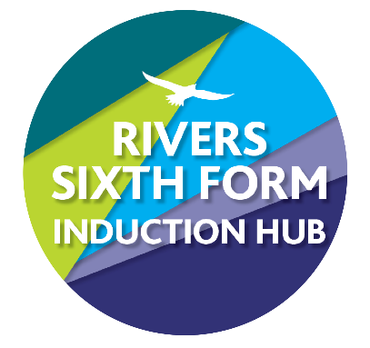
SUBJECT: Digital Media
RIVERS TRANSITION CHALLENGE 2024
Course details: Exam board OCR
Qualification: Extended Certificate in Digital Media

Minimum entry requirement is: GCSE Maths and English Grade 4 or OCR Creative iMedia: Level 2 Pass
Teachers: Mrs Gibson dgibson@ormistonriversacademy.co.uk
Mr Lawman olawman@ormistonriversacademy.co.uk

YOUR CHALLENGE:
Challenge : Use basic and advanced tools on Photopea
- You will use Photopea online https://www.photopea.com/
- You will need to watch `how to` Videos- There are plenty! The best ones to use are Sue Farrimond`s https://sites.google.com/view/suefarrimondtutorials/image-editing-and-creation/photopea-basics
- The expectation is that you create a Word document that will become your log of the tools you have used.

How it links to the Specification:
The skills that you learn will enable you to have a better understanding of what is possible when creating a printed media product- this will aid in your planning and design and of course when you actually make the product

Time guide: 3-5 hours total:

EXEMPLARS: I have attached a Knowledge map that lists some of the basic and advanced tools available to you-

The word document: Name it “Skills Log”- you can use images from the internet (you must reference the images you have used – a reference will look like this: https://netballamerica.com/wp-content/uploads/1DX28219.jpg

So:
- Watch Sue Farrimond’s Video lesson 1- The find an image- reference it as below
- Print screen your original image
- Use the tool as shown in the video
- Print screen you using the tool and the finished image
- Repeat for the next video

You will need to have tried all the tools in the advanced- some take seconds – remember I will expect 3-5 hrs worth of work

SUPPORT:
-Watch the videos
https://sites.google.com/view/suefarrimondtutorials/image-editing-and-creation/photopea-basics

https://www.youtube.com/watch?v=a3aPaTNV5g4

HOW DO I HAND IN:
Your work bring your work to your first IT lesson in September so that it can be assessed and marked accordingly.

HOW AM I GRADED DURING YEAR 12 and 13?
You are graded using Level 3 Distinction, Merit, Pass, Near Pass, or U. Level 3 is a big jump and so you will need to spend significant time learning the concepts and techniques and refining your writing.

We would expect new students to any course to be sitting at the bottom of the grading structure towards the beginning of Year 12 but there are certain activities that you will be familiar with and will do better with even though it's just the start of the course. Please don't worry if you receive U grades or Pass grades on your first assignment. Where there is major concern, we will ring your parents and carers throughout the year to be able to speak to them and you about how to provide support or the suitability of the course.

WHAT IF I GET STUCK?
Then email us! Our emails are in the title of this sheet or write on the thread in our classroom, we know some things are tricky and are here to help!

WHAT IF I MISS A DEADLINE OR DON’T HAVE IT?
You must speak to us in advance if you are going to miss a deadline. We know people are sick, and sometimes we have other commitments but usually work that isn’t complete is down to students waiting until the last minute and then not having enough time to understand or complete the task.
If you email us in advance, we can support you. If you just miss the deadline, you are risking your course offer as you may not be suitable for the course. It is a big jump from Key Stage 4 to 5, but we also don’t want to sign a student up for a two year course if they aren’t going to be successful.

WIDER READING/ACTIVITIES TO KEEP YOU BUSY IN THE SUMMER
Books:
Digital Culture: understanding new media by Glen Creeber and Royston Martin
Key Concepts and Skills for Media Studies by James Baker

Watch:
James Bond - `No time to Die`
Encanto

