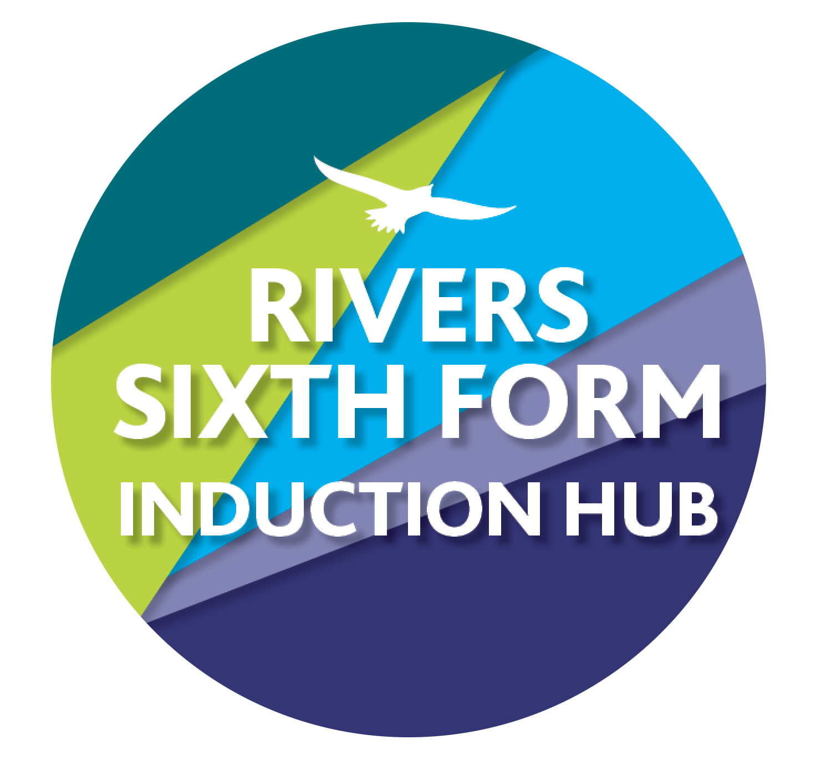
RIVERS BRIDGING WORK 2024
SUBJECT: Art
Course details: OCR
Qualification: A Level

Minimum entry requirement: Grade 4 in Art and Design or a portfolio of work
Teacher: Ms N Nicoll
nnicoll@ormistonriversacademy.co.uk

SUMMER BRIDGING TASKS:

Over your break you must create a body of work and drawings from the starting points listed below.
We would like you to go for a walk or journey and take photos which link to the list of “somethings” below. We would then like you to use these photos as the starting point for a series of drawings and responses which will be brought to your first sixth form lesson in September.

Please take a series based on the “somethings” below , select your best 15 and then produce outcomes from these .
- Something monumental
- Something animal
- Something old
- Something reflective
- Something miniscule
- Something linear
- Something hidden
- Something discarded
- Something smooth
- Something hard
- Something soft
- Something broken
- Something aggressive
- Something patterned
- Something out of place
- Something lost
- Something happy
- Something sad
- Something textured
- Something fragile
- Something decayed
- Something suspended
- Something sheltered
- Something wrapped
- Something logical

Your project should include the following outcomes (which should be based on your photographs of “something”)
Four a5 pencil drawing, full tone and textural mark making drawings.
Two a4 fineliner drawings using cross hatching in the style of Morandi
Two a4 colour montages using photos, card, magazine cuttings ect. Based on your photos.
1 a4 watercolour painting based on your photos.

Have fun with it and we’ll see you in September with your lovely work.

HOW DO I HAND IN?
You need to present your effort at the beginning of the autumn term.

WHAT IF I GET STUCK?
Then email me, my email is at the top of this sheet..

THAT'S IT! Have a great summer and I look forward to starting the course properly with you in September.

