DISAD VAN TA GED THREE YEAR STR ATEGY
OU R MISSIO N & BELIEF S
Our students, regardless of socio-economic background, should all progress equally. The life chances of those with disadvantaged financial backgrounds should be equal to those that do not have that challenge. Our drive towards equality of experience, enrichment opportunities and exam outcomes for all is at the heart of our academy intentions. We believe that what happens in our classrooms in every period of every academy day is what makes the difference. As such we use our PP funding to provide a wide programme of support so that learning opportunities can be accessed without question or excuse. After all, higher attainment creates life chances and life choices.

The Pupil Premium (PP) is additional funding allocated to schools on top of the main funding that they receive. This funding is targeted at students from disadvantaged backgrounds (eligible for Free School Meals or In Care) to ensure that they are able to benefit from the same opportunities as students from less disadvantaged families. Data suggests that students who have been eligible for Free School Meals at any point in their school career have consistently lower attainment than those who have never been eligible.

Since September 2014, the Pupil Premium is worth £935 and goes to students who at any point in the past six years have been in receipt of Free School Meals (FSM); £2300 goes to any student who has been continuously looked after for the past six months or who has been adopted from care under the Adoption and Children Act 2002 or who has left care under a Special Guardianship or Residence Order; finally £300 goes to students whose parent/ parents are currently serving in the armed forces or are in receipt of a pension from the MoD.

What the evidence shows: What happens in the classroom makes the biggest difference: improving teaching quality generally leads to greater improvements at lower cost than structural changes. There is particularly good evidence around the potential impact of teacher professional development; but the supply of high quality training is limited.

What the evidence shows: Targeted small group and one-to-one interventions have the potential for the largest immediate impact on attainment. Some wholeclass and whole-school interventions have shown promise but may take longer to show results.
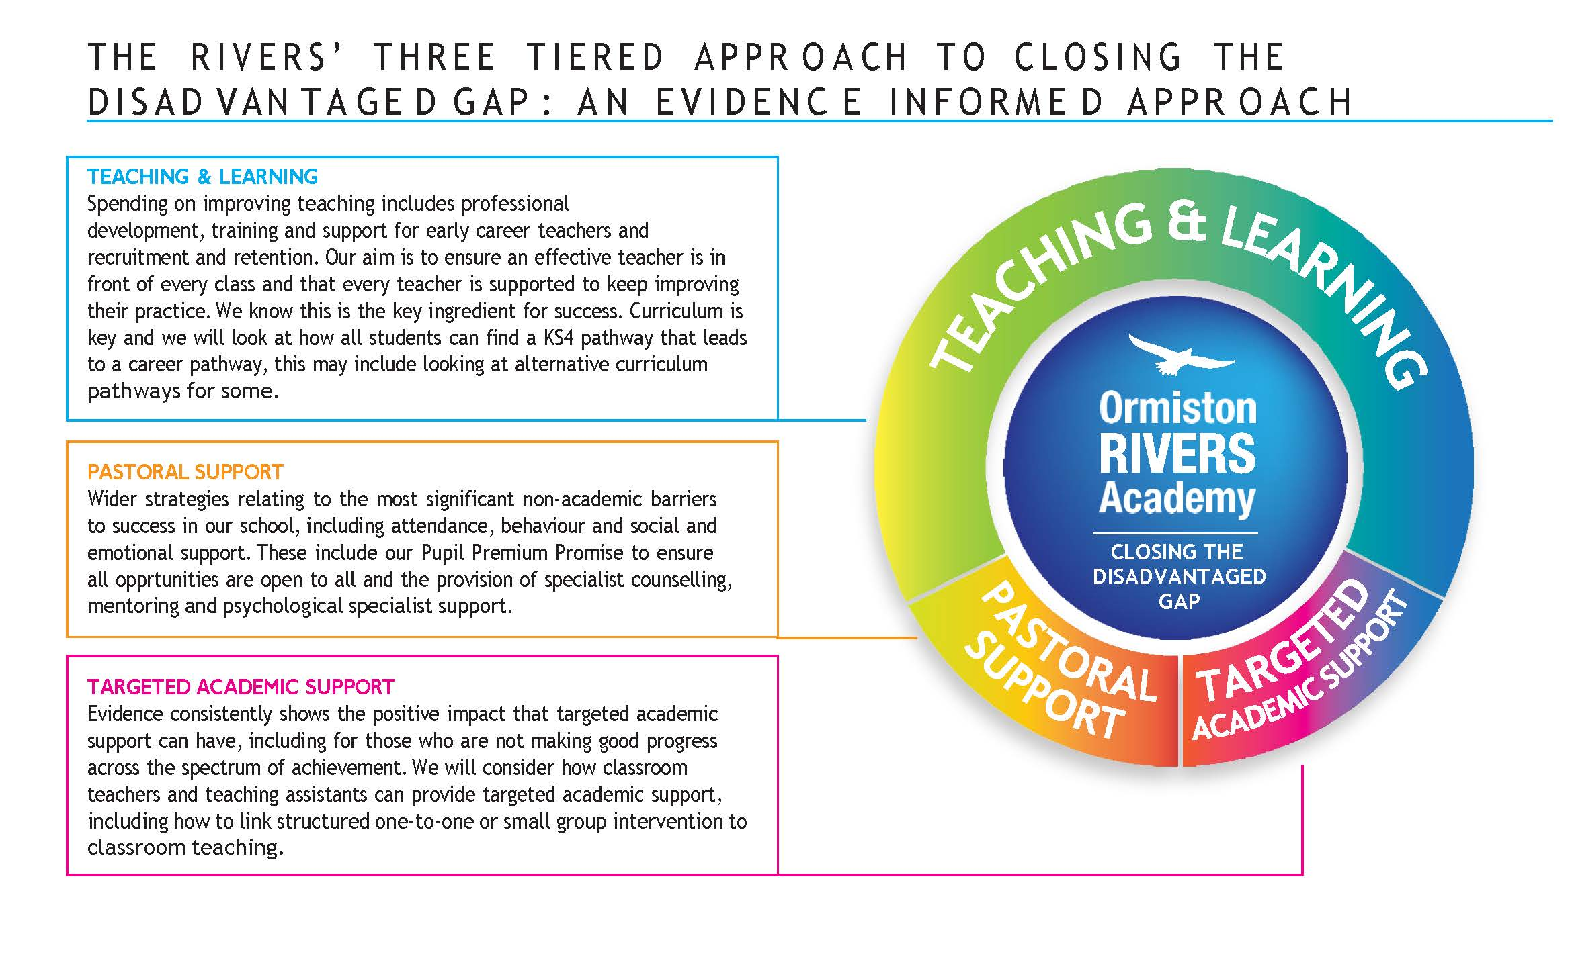
L
A
T
R
R
O
O
P
T
P
S
U
A
S
P
N
G
T
T
E
R
D
O
E
P
P
T
U
E
S
C
G
I
M
R
E
D
A
A
C
T
A

THE RIVERS’ THREE YEAR DISADVANTAGED STRATEGY

 | 2023-2024 | 2024-2025 | 2025-2026
Teaching  &  Learning | - All staff embed Rivers’ way when planning lessons.  - Improve AFL  - Improve Feedback of?  - Introduce Homework monitoring system  - Review all subject Curriculum to ensure PP...?  - Assessment displayed on digital system (G4S) visible to parents, careers and students.  - G4S Seating plan embedded into planning  - Introduce T&L Coaching programme  - Introduce regular feedback via lesson drop-in procedure | GFL  Embed a culture of sharing best practice, with quality first teaching at the forefront  Embed a culture of staff feedback to ensure CPD  Develop peer-to-peer coaching program where the goal is for all staff to be coached  Ensure quality of homework – enrich...etc
Targeted  Academic support | - Super 6 Intervention student autonomy Y11 & Y13  - 1:1 / small group targeted support in English & Maths  - Morning Intervention twice per week for English, Math & Science  - Underperforming PP students identified and department / curriculum based intervention applied  - Pupil Premium Team.  - English KS3 PP lead  - English KS4 PP lead  - Maths KS3 PP lead  - Maths KS4 PP lead  - Science PP lead | - Super 6 Intervention student autonomy Y11 & Y13  - 1:1 / small group targeted support in English & Maths as required.  - Morning Intervention twice per week for English, Math & Science as required.  - Underperforming PP students identified and department based intervention applied as part of normal departmental practice.  - Pupil Premium Team.  - English KS3 PP lead  - English KS4 PP lead  - Maths KS3 PP lead  - Maths KS4 PP lead  - Science PP lead | - Super 6 Intervention student autonomy Y11 & Y13  - 1:1 / small group targeted support in English & Maths as required.  - Morning Intervention twice per week for English, Math & Science as required.  - Underperforming PP students identified and department based intervention applied as part of normal departmental practice.  - Pupil Premium is an integral part of all curricula and monitoring.
Pastoral | - Embed behaviour points system (G4S)  - External counseling providers into school support plan  - Deploy a full-time attendance officer  - Attendance tracking system for HOYs and regular meetings with attendance officer to plan interventions  - Use of Bear, the school dog, to support PP students with anxiety and attendance  - Rewards scheme for attendance and positive behaviours  - Ticket to the prom scheme for Year 11  - SSA preventative focus groups:  - Sisters in strength  - Social skills  - Anxiety  - Conflict resolution/antibullying  - Bridge provision to support students with behaviour and teach skills needed to make a success of mainstream education  - Pupil Premium Team.  - Disengaged Mentor  - Attendance Mentor x2 | - Individual support plans and mentoring in place for identified PP students for attendance, behaviour and/or progress needs  - SSA preventative focus groups expanded to cover a wider range of interventions  - Rewards embedded into departments and pastoral teams for all year groups  - Enhanced range of PP focused trips and speakers to raise aspirations  - Brilliant club or alternative University linked opportunity to raise aspirations of PP students  - Pupil premium team continue to develop mentoring and targeted interventions  - Bridge provision  - Range of support opportunities in place from external agencies and Learning Authority | - Individualised support plans and mentoring for all PP students  - Enhanced rewards scheme per year group  - Wide range of preventative focus groups offered to targeted PP students  - All staff focused on attendance and clear department led catch up process in place to support individuals to close gaps made by absence  - Pupil premium mentor for each year group  - Separate KS3 and KS4 Bridge alternative provision in place to support students with behavioural needs and teach students the skills needed to succeed in mainstream
Literacy | - Read aloud programme tutor time x2 Y 7-10  - Lexonik Adavnce and LEAP.  - Reading Scholars Programme  - Access to the LRC before school, during break and lunch and after school  - Lexonik Vocabulary Cloud to develop vocabulary gaps in the classroom.  - CAT4 and NGRT reading tests to identify gaps  - Book Buzz Programme  - 7 & 8 Library Lessons take place once every two weeks for one hour.  - Jack Petchey Speak Out Workshops for 60 Year 10 students.  - Library initiatives with prizes and rewards.  - Book club, debate club and competitions open for all year groups. | LSS  - Continue Library lessons for Year 7 into Year 8, introduce to new Year 7s.  - Continue Lexonik and LEAP  - Staff to be aware of reading abilities in their classrooms by using data accessible to them.  - Establish Extra Curricular Clubs and encourage more students to join.  - Develop Read Aloud Programme to ensure all students engage in the form time activity.  - Embed the explicit teaching of vocabulary in the classroom.  - Continue to reward students regularly for their contributions to Literacy and competitions.  - Continue the Book Buzz programme and encourage more student interest. | - Open Library Lessons to all of KS3.  - Enter competitions with teams created in extra- curricular clubs.  - Staff confidence in teaching vocabulary and reading explicitly in the classroom.  - To continue to progress with Lexonik Advance stages, LEAP and Lexonik Vocabulary Cloud.  - Continue to develop strategies for 1:1 intervention.  - Continue Read Aloud in form time sessions.

THE RIVERS’ THREE TIERED APPR O A CH:
A N EVIDENC E INFORME D STR A TEG Y
Closing the attainment gap: key lessons learned in the EEF’s (Education Endownment Funds) first six years.
vital that schools (as well as early years and post-16 settings)

Early Years education has huge promise in preventing the attainment gap becoming entrenched before children start school. However, it has not – yet – yielded as much as it should. Professional support and training for early years workers is key. Areas with potential include communication and language approaches; self-regulation strategies; and parental involvement.

What happens in the classroom makes the biggest difference: improving the quality of teaching quality generally leads to greater improvements at lower cost than structural changes. There is particularly good evidence regarding the potential impact of teacher professional development; but the supply of high quality training is limited.

Targeted small group and one-to-one interventions have the potential for the largest immediate impact on attainment. Some wholeclass and whole-school interventions have shown promise but may take longer to show results.

The transition between phases of education – notably early years to primary, and primary to secondary – is a risk-point for vulnerable learners. Schools need to diagnose pupils’ needs as soon as possible
in order to put in place effective support to help those falling behind to catch up.

The challenge of improving post-16 attainment is a particular issue for students from disadvantaged backgrounds. A majority of students eligible for free school meals have not achieved a good standard
in English and mathematics by age 19. More evidence is needed to identify the best ways to improve outcomes for these learners.

Pupil Premium funding is a valuable tool in supporting senior leaders in raising the attainment of disadvantaged young people. But it is

consider how all their resources can be used to achieve this goal. Good teaching for all pupils has a particular benefit for disadvantaged pupils.

The £5 billion per year asset of teaching assistants could be deployed more effectively. Though previous research had suggested that teaching assistants can have a negative impact on children’s learning, EEF trials have shown how, when properly trained and supported, teaching assistants working in structured ways with small groups
can boost pupils’ progress. How a project is implemented is vital and arguably as important as its content. Successful projects have
clarity around their structure, objectives and target group, with high- quality training and materials that allow for adaptation and strong implementation. The EEF’s forthcoming guidance report, ‘A School’s Guide to Implementation’, draws out what we have learnt over the last six years.

Schools can make a difference
Closing the attainment gap between disadvantaged children and their peers is the greatest challenge facing schools.
The gap is stubborn because its causes are entrenched and complex, and most lie beyond the control of schools and educators. However, it is clear that schools can make a difference. In
England, the gap has closed in both primary and secondary schools since the introduction of the Pupil Premium, and in every
part of the country, schools have demonstrated how great teaching and careful planning can make a huge impact on the outcomes
of disadvantaged children.

Quality teaching helps every child
Good teaching is the most important lever schools have to improve outcomes for disadvantaged pupils. Using the Pupil Premium to
improve the quality of teaching benefits all students and has a particularly positive effect on children eligible for the Pupil Premium. While the Pupil Premium is provided as a different grant from core funding, this financial split shouldn’t create an artificial separation from whole class teaching.

Support middle and high attainers too
The causes and consequences of disadvantage are varied: Pupil Premium students are not a homogeneous group. Students eligible for the Pupil Premium are more likely to be low-attaining than other children. However, tackling disadvantage is not only about supporting low attainers. For example, disadvantaged students who achieve highly in primary school are much less likely than their peers to achieve top grades at GCSE.

School Implementation Process: Implementation matters
The challenge of implementation means that less is more: selecting a small number of priorities and giving them the best chance of success is a safer bet than creating a long list of strategies that becomes hard to manage.

Research Sources:
+ Education Endowment Foundation: evidence-summaries
+ UK Government: State of the Nation 2018-19: Social MObility Rport
+ Widening participation in higher education amongst students from disadvantaged socio‐economic groups: Tamsin Bowers‐Brown
+ Educaiton Policy Institute Annual Report 2019: The education disadvan- tage gap in your area

PUPIL PREMIUM: EVIDENCE B ASED SPENDING FOR IMP A CT

The Education Endowment Foundation (EEF) is an independent charity dedicated to breaking the link between family income and educational achievement.

The attainment gap: the school perspective
+ The attainment gap is not a problem found only in schools assessed by Ofsted as performing poorly – the gap is as large in schools rated ‘Outstanding’ as it is in schools rated ‘Inadequate’.
+ There does not appear to be a direct relationship between increased school funding and increased pupil attainment – what matters most is how schools can effectively and efficiently use the resources they
have (both financial and human) for maximum impact.
+ The Pupil Premium is a valuable focus for closing the attainment gap – but it is important schools consider how they can best use all their resources to improve the quality of teaching, as this will benefit all pupils, but particularly the most disadvantaged.
+ One region, London, stands out for its success in improving attainment for disadvantaged pupils and closing the gap.
+ There is huge variability in outcomes for disadvantaged pupils between schools with similar levels of disadvantage.

+ In 10% of primary schools and 8% of secondary schools, disadvantaged pupils are doing better than the national average for all pupils. This shows it is possible to narrow the attainment gap – if we can find effective ways to learn from the successes of the best-performing schools, and achieve greater consistency between similar schools.
+ Schools where disadvantaged pupils are currently attaining below the average of disadvantaged pupils in similar schools should consider how they can help those young people to at least reach that average level of attainment as an initial goal.
+ Reaching this goal would make a big difference – both in improving the outcomes of disadvantaged pupils and in closing the overall attainment gap.

The attainment gap: its impact on children and young people
The attainment gap is largest for children and young people eligible for free school meals (the best available proxy measure of economic disadvantage) and those assessed with special educational needs.
+ The gap begins in the early years and is already evident when children begin school aged 5.
+ The gap grows wider at every following stage of education: it more than doubles to 9.5 months by the end of primary school, and then more than doubles

again, to 19.3 months, by the end of secondary school. This shows the importance of intervening early and then of continuing to attend to the needs of disadvantaged pupils.
+ A majority of 19 year-olds who have been eligible for free school meals leave education without a good standard of recognised qualifications in English and maths – without which, achieving their goals in the world of work or further study will be much harder.
+ While the attainment gap has reduced a little over the past decade, it remains significant. The current slow progress in narrowing the gap means it will persist for decades.
+ Our forecast of the attainment gap for the next five years suggests some positive progress for free school meal-eligible pupils in GCSE English and maths; but no headway on Attainment 8 and a widening of the gap in Progress 8.
+ Even small improvements in young people’s GCSE qualifications yield significant increases in their lifetime productivity returns and in national wealth – highlighting the importance of continuing to focus on improving results for currently low-attainment

We promise to provide the following for all our Pupil Premium students to maximise your chances of success:
+ High quality teaching and regular homework, alongside challenging and ambitious targets for what you can achieve
+ A Home Study Pack with all the equipment you need to be successful at school, including Revision Guides a Scientific calculator and stationery.
To get one of these just email Mrs Mahoney on amahoney@ormistonriversacademy.co.uk
+ Access to ICT equipment and colour printers each day after school in the Library to help you with coursework and homework
+ Daily Homework Club: a space for you to work after school each night of the week in the Learning Resource centre and library
+ Subsidised trips so you can attend local, national and international trips and visits. Contact Mrs Mahoney (email above)
+ Free transport every night via our late bus so that you can attend any extra-curricular activity
+ Free Breakfast (Including Breakfast club) or Snack at break
+ A dedicated Pupil Premium phone-line for parental support or help with transport emergencies, 8am-4pm Monday-Friday. 01621 787823
+ Priority access to Careers guidance bookable direct though Louise Brazier on lbrazier@ormistonriversacademy.co.uk
+ Access to 1-1 Free Music lessons for those that show musical interest via Miss Thurtle on CThurtle@ormistonriversacademy.co.uk
+ Access to higher education trips to Careers Fairs and Universities to raise your aspirations via Mrs Compton on fcompton@ormistonriversacademy.co.uk
+ Booster sessions and 1:1 tuition
+ Access to help with buying school uniform via Mrs Mahoney on amahoney@ormistonriversacademy.co.uk
+ A wide range of Period 6 lessons to support you in the run up to your exams (and after school clubs and sports teams for all.)
+ Drop in access at break and lunches to pastoral support from our team of student support officers and Wellbeing Warriors
+ A dedicated Senior Leader to support all Pupil Premium Families

